Delavan United Methodist Church
213 S. Second Street
Delavan WI 53115

AUGUST 2025 TOWER

Address Service Requested



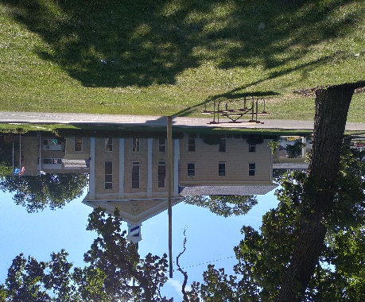
Delavan United
Methodist Church
213 S. SecondSt.
Delavan WI
(262) 728-3644

AUGUST 2025 TOWER


Please join us!
Worship 10:00 a.m.
Fellowship 11:00 a.m.
Spanish Worship 12:30 p.m.

COMING EVENTS:

Saturday, August 23, 2025
PORK CHOP DINNER
3:30 – 6:30 p.m.
Details inside!


We wish God’s blessings to those of you celebrating a birthday or anniversary in August. Please notify the church office of any additions or corrections.

Gene Gallup August 1
Chris Pelnar 2
Jerry Vance 5
Jessica Rima 10
Anita Ryan 24
Don & Jean Hummel 25
Happy 69th Anniversary Don & Jean!
Joanne Howe 28
Pat Brown 31
NOISY CANS
Our Noisy Cans are passed during the offering on Sunday mornings. The proceeds are then totalled at the end of the month and benefit a local charity, our Food Pantry, or Pastor’s Discretionary Fund. In August our donations will benefit Northcott Neighborhood House in Milwaukee. In July we collected $92 for school supplies. Thank you for your contributions to our Noisy Cans!


Our Fall Rummage & UWF Bake Sale will be held Friday & Saturday, Sept. 19 & 20. If you have items to bring for the rummage sale, please place them upstairs in the Sunday School room (or if you can wait until 2 weeks before the sale you can place the items in the Library). 1
DELAVAN UMC CHURCH STAFF

Pastor: Angel Rosario Church: 262-728-3644
Home: 262-725-6203
E-mail: delavanumcpastor@gmail.com
Pastor’s Office Hours: 8 a.m. – 12 p.m. Tues. – Thurs.

Secretary: Jeanne Esch Cell: 262-233-0453
E-mail: delavanumcwi@gmail.com
Office Hours: 8 a.m. – 1 p.m. Mon. – Thurs.

Custodian: Paul Esch Cell: 262-745-2885

Pianist: Laurie Hallmark Cell: 608-728-1372

Pianist: Clarissa Marquez Cell: 262-492-6855

Mission Statement
We strive to love God with open hearts, minds, and souls,
and to love our neighbors as ourselves.

Vision Statement
The people of Delavan United Methodist Church are committed to deepening our understand, living, and sharing of our faith by worshiping God and reaching out to members of the community, regardless of age, race, ethnic origin, gender or economic status, sexual orientation, mental or physical ability.

The people of the United Methodist Church
Live the Fruit of the Spirit

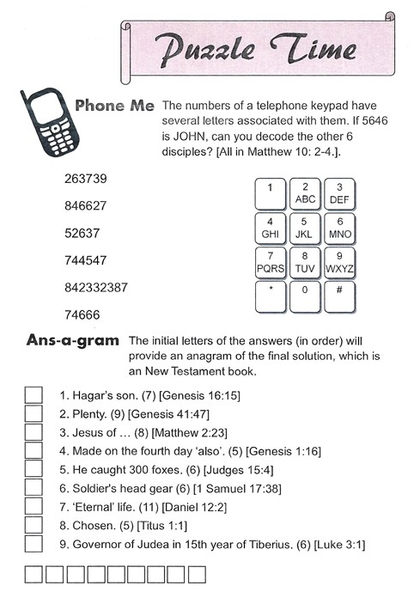
Answers to Phone Me: Andrew, Thomas, James, Philip, Thaddaeus, Simon.
Answers: Ans-a-gram: 1. Ishmael, 2. Abundance, 3. Nazareth, 4. Stars, 5. Samson, 6. Helmet, 7. Everlasting, 8. Elect, 9. Pilate. Solution: Ephesians.
12
On Sunday, July 20th we had a special coffee hour celebrating Joyce Francis’ 103rd birthday. Pictured below are Joyce, and Joyce with her son, Don.

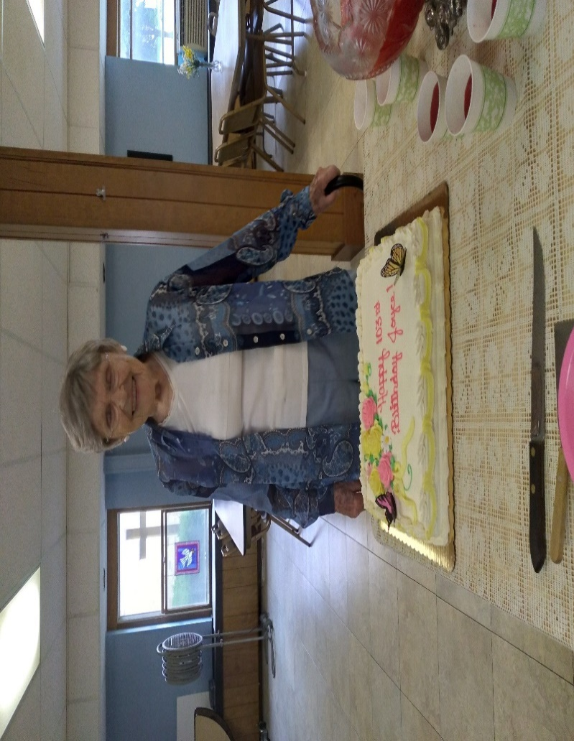

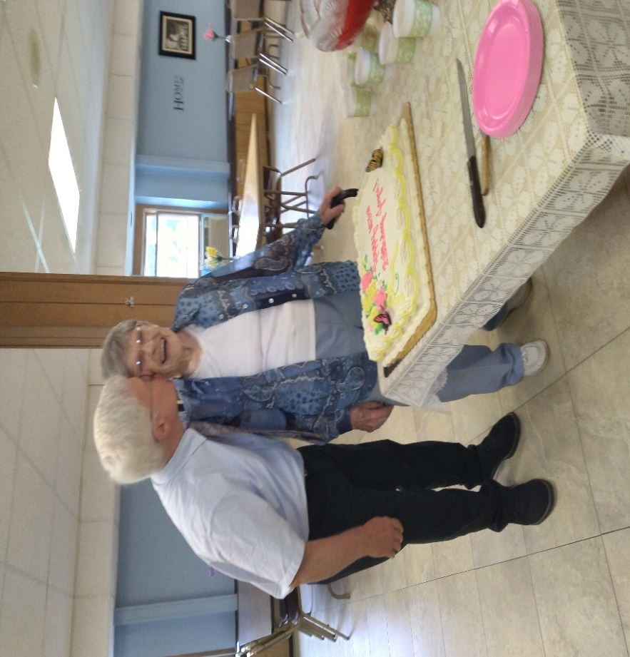
2
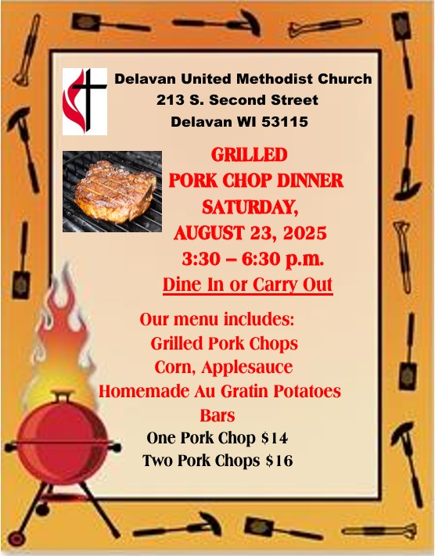
Tickets will be available August 4th. Stop by the church office to purchase your tickets. We need lots of help to make this dinner a successful fund raiser! If you can help, please sign up! Sign-up sheets are on the table in the Fellowship Hall. Donations of milk, butter, potatoes, corn, and bars would be appreciated!
3
United Women in Faith (con’t)
United Women in Faith is a missional organization dedicated to missions for women, children and youth, and creative opportunities for women to serve and grow in their faith. They serve as an advocate for many justice issues besides providing spiritual growth and service opportunities for their members. Last year, we gave mission money to UMCOR, Northcott Neighborhood House, Rooted & Rising-Washington Park, Wal/Co Child Advocacy Center, The Time is Now to Help, Call to Prayer & Self-Denial, New Beginings, the Food Pantry, and the Upper Room magazine for our local church, and more. God bless you in your service. Chris Anding


Please keep the following members and friends in your prayers:

For healing and strength: Moe Mawhinney, Phyllis Almburg, Van Brown, Don & Jean Hummel, Gene Gallup, Ann Scott, Brady Kavanaugh, Jacob Blair, Leona Kruizenga, Pat Wierenga, Steve Jones, Donna Brellenthin, Paul Holman, Joe Guzman, Jeff & Carrie Dixon.


Darien Community of Christ United Methodist Church will have their Fall Rummage & Bake Sale on Friday, September 5 from 8-3 and Saturday, September 6 from 8-2. Saturday will be their all day $4.00 bag sale.
11

Delavan United Women in Faith
August 2025 Happenings

How do you live out your faithfulness in a changing world? We were asked that question for the August program. When the storms of life are raging, where do you turn? These things we are to consider among our family, friends, and work environments. Do we trust God enough to help us?

Our next meeting, Thursday, August 14 at 10:00 a.m. in the church library will be to designate our mission money through our 5 channels of giving. We will also fill out the Mission Today form for the SE District and talk about having a bake sale with the rummage sale Sept. 19-20. Our Conference Membership Nurture & Outreach Coordinator, Katrina Willis, will be at the meeting to talk to us about our destiny. You are invited to join us.

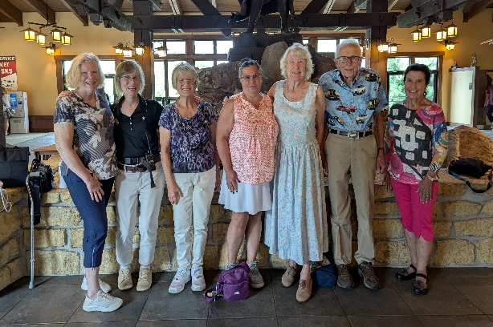
Our fun trip to House on the Rock in Spring Green was a joy-filled experience. Five us from Delavan and the Unit President from Merrrimac made up the group. The Director, Nancy Schaaf, met us at the front door, provided our tickets and became our tour guide, telling us the story of the landmark. We shared many spectactular experiences – going out in the Infinity Room, hearing the mechanical orchestras play, viewing the Japanese Garden, the Carousel and more.
(con’t on pg. 11) 10
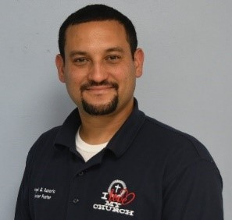
Pastor Angel’s Page
“His Favor Still Available”
“The Spirit of the Lord is upon me, for he has anointed me to bring Good News to the poor. He has sent me to proclaim that captives will be released, that the blind will see, that the oppressed will be set free, ¹⁹ and that the time of the Lord’s favor has come.” Luke 4: 18-19
This scripture is the account of Luke when Jesus went to the synagogue in Nazareth after he successfully rejected the Devil’s temptations. He was handed the scroll of the prophet Isaiah. Jesus purposely read only this part to everyone that was there, then he sat down and began to teach that this prophesy was fulfilled in him that very same day. This was the beginning of Jesus’ ministry. I believe that here is when the favor of the Lord started but it wasn’t just for that time, the favor of the Lord is still available today.
Many Christians believe, they have to somehow, earn the favor of God, but the truth is we already have his favor. It began hundreds of years ago in Jesus. God’s favor is the power that changes the circumstances in our favor. Jesus already earned this favor by his death and resurrection. Even though things around us may seem otherwise, God’s favor is upon us. From the moment we repented and gave our life to Christ, God’s favor began working nonstop on our behalf. This doesn’t mean that we are going to be perfect and can’t make mistakes, on the contary, it means when we make mistakes that is exactly when his favor works best.
The enemy may accuse you of your faults before the Father; Jesus will defend you because of his sacrifice; then God will forgive you because of his favor. I want to leave you with this blessing that God gave the people of Israel through his servant Moses. It is found in the book of Numbers 6: 26 “May the Lord show you his favor and give you his peace.”
Pastor Angel Rosario
4

In most of these articles, I write to tell you how things are going in the pantry and how many families we have helped recently. This month, I want to share a story of how another pantry in the county helped our pantry with an important need.
Cereal, both sweetened and plain, has been expensive and a scarce item to find at a reasonable price. At the July meeting of the Wal/Co Food Pantry Coordinators, we shared this challenge. Jack, the Coordinator of the Emergency Food Pantry in Walworth, said he had more cereal that he could distribute before it was out of date. We arranged to meet Jack at the Bridge Pantry in Elkhorn on Monday mornings when each of us picks up our orders delivered there from Feeding America. Jack brought 3 large boxes filled with a variety of cereal which allowed us to supply our families with a choice of several cereals.
Psalm 107 begins with the following three verses:
O give thanks to the Lord, for he is good,
for his steadfast love endures forever.
² Let the redeemed of the Lord say so,
those he redeemed from trouble ³ and
gathered in from the lands, from the east
and from the west, from the north and
from the south.
We are thankful for the “steadfast love” of God who blesses us in many ways. When there seemed to be no way to find cereal at a reasonable cost, God revealed a way that provided cereal at no cost. Those of you that are old enough to remember the Red Green Show that ran on PBS for many years will probably remember Red’s signature saying : We’re all in this together. This is true of our pantry and its mission – we’re all in this together.
(con’t on pg. 6) 5
I loved it, and it was just the right size for me. I don’t remember what he paid for it. Our mailbox was situated a quarter mile away on a gravel road; when I got the mail I would stop to peer into the open metal fence post and see the bluebird’s nest. I could then turn onto Blaen Cae Rd. (Welsh name), and ride on the blacktop. I could ride to Sam’s station a mile away to pick up a loaf of white bread for Mom, and maybe have a nickel left to get a bottle of Pepsi out of the red cooler.

I could ride to different friend’s houses; distance didn’t matter. Once I rode all alone along Hwy. 73, a couple of miles beyond the town of Randolph to my cousin Jane’s home. I guess we didn’t worry about this 7 mile ride without a cell phone, water bottle, sunscreen, or helmet – or what would I do if something went wrong. Nothing happened, and I arrived safely at Jane’s home that night. Mom and Dad came over for coffee, put the bike in the truck, and we went home.

One time I remember trying to repaint my bike; I did it in the barn, which was a mistake, because flies kept getting stuck on it. Sadly, I don’t remember what happened to my trusty little bike. It was probably passed down to my sisters, or some other cousin. I do remember the feeling of flying down the blacktop at full speeed, my blonde hair flying in the wind, and the pleasure of doing this pain free.

Yes, the gravel road is still there – but now it’s paved and called Dykstra Road, my family name. The mailbox is now at the end of the farm’s driveway. The barn is gone and memories with it.

P.S. On my 60th birthday, I received a new retro Schwinn – no gears; it was my first new bike. 9
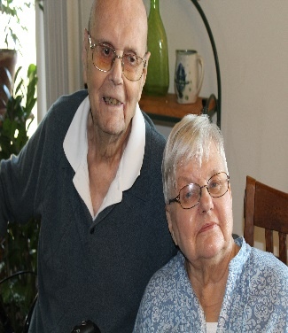
The following is a story written by Ann Scott. It’s called “My Very Best Gift”.
Enjoy!

“My Very Best Gift”

It didn’t come at Christmas – it wasn’t wrapped and it wasn’t new. It just happened to come one hot summer day when I was 9 or 10. My gift was a used girl’s bicycle. We live on a farm with a very old, small house. It didn’t have running water and a bathroom – or even electricity in my early years. Dad and Mom had come through the Depression, and my Uncle Rink had mortaged his farm, so Dad could buy this 90-acre farm down the road from Uncle. There were a lot of hand-me-downs, used and re-used objects. Dad and Uncle Rink could repair everything, and Aunt Rena was very adept at making new things out of old, like my brother’s teddy bear made from an old fur coat.

I was learning to ride on Cousin Hank’s old boy’s bike, which was full size. Boy’s bikes had a thick metal crossbar down the middle. I lined it up with this old stone wall, climbed on and took off. I had to stand up to reach the pedals and brake, but each time I just had to tip over and fall in order to stop. After many skinned knees and elbows and a bruised bottom from hitting the crossbar, I finally learned to ride. But, invariably, I still had to fall over when stopping.

One day, Dad came home from Friesland after having been to the feed mill with his pick-up. He called me over, and in the back of the pick-up lay this used, blue girl’s bike, not quite full size. He had bought it from our minister whose daughter had outgrown it.
8
Thank you for helping to feed the 30+ families we serve each week. It’s your steadfast love and commitment reflecting the love of Christ that makes life better for so many.

Items we regularly need are:

Ketchup/Mustard Elbow Macaroni
Hamburger/Tuna Helper Chunky Peanut Butter
Jelly Salt/Pepper
Spaghetti Sauce with Meat Chicken Noodle Soup
Pork & Beans Tomato Soup
Mushroom Soup Refried Beans
Tortillas Fruit Cocktail
Peaches
Rev. Ed Foster, Coordinator
DUMC Food Pantry



WORSHIP ATTENDANCE AND RECEIPTS
Date | Attendance | Receipts
7/6/25 | 29 | $2404
7/13/25 | 27 | $5460
7/20/25 | 43 | $2794
7/27/25 | 45 | $889
Amount that we need each month for expenses: $13,879.00. In July we received $11,547 (-$2332). (Please note that some of the monies received were for the Food Pantry and Noisy Cans.
6

Sunday | Monday | Tuesday | Wednesday | Thursday | Friday | Saturday
 |  |  |  |  | 1  9 am OA (L)  10 am AA (CR) | 2
3  10 am Worship  11 am Fellowship  11:30 am SBP  12:30 pm Spanish Worship | 4 | 5  2 pm Bridging the Gap (FH)  5 pm TOPS (FH) | 6  9-12 Food Pantry  7:30 pm AA (CR) | 7  6-8:30 pm Bethel Bible Series at Chapel on the Hill | 8  9 am OA (L)  10 am AA (CR) | 9
10  10 am Worship  11 am Fellowship  11:30 am SBP  12:30 pm Spanish Worship | 11  5 pm FINANCE COM. (L) | 12  2 pm Bridging the Gap (FH)  5 pm TOPS (FH) | 13  9-12 Food Pantry  1:00 pm Area Food Pantries (L)  1:00 pm Delavan Serv. League (FH)  7:30 pm AA (CR) | 14  10 am UWF (L)  6-8:30 pm Bethel Bible Series at Chapel on the Hill | 15  9 am OA (L)  10 am AA (CR) | 16
17  10 am Worship  11 am Fellowship  11:30 am SBP  12:30 pm Spanish Worship  3 pm Vida Ab. (FH) | 18 | 19  9 am Food Pantry Meeting (FH)  2 pm Bridging the Gap (FH)  5 pm TOPS (FH) | 20  9-12 Food Pantry  6 pm COUNCIL  7:30 pm AA (CR) | 21  Pork Chop Dinner Prep (K)  6-8:30 pm Bethel Bible Series at Chapel on the Hill | 22  Pork Chop Dinner Prep (K, FH)  9 am OA (L)  10 am AA (CR) | 23    PORK CHOP DINNER  3:30-6:30 pm
24/31  10 am Worship  11 am Fellowship  11:30 am SBP  12:30 pm Spanish Worship | 25 | 26  2 pm Bridging the Gap (FH)  5 pm TOPS (FH) | 27  9-12 Food Pantry  1 pm Delavan Serv. League (FH)  7:30 pm AA (CR) | 28  6-8:30 pm Bethel Bible Series at Chapel on the Hill | 29  9 am OA (L)  10 am AA (CR) | 30
SBP=Spanish Band Practice; FH=Fellowship Hall; CR=Community Room; L=Library; K=Kitchen
TOPS=Take Off Pounds Sensibly; OA=Overeaters Anon.; AA=Alcholics Anon.

