DELAVAN UNITED METHODIST CHURCH
213 S. SECOND STREET
DELAVAN WI 53115

OCTOBER 2025 TOWER

ADDRESS SERVICE REQEUESTED



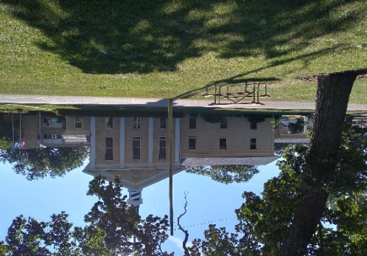
Delavan United
Methodist Church
213 S. Second St.
Delavan WI 53115
(262) 728-3644

OCTOBER 2025 TOWER

Please join us!
Worship 10:00 a.m.
Fellowship 11:00 a.m.
Spanish Worship 12:30 p.m.

COMING EVENTS

HARVEST DINNER
Wednesday, October 29
4:00-6:30 p.m.
Drive-Thru Only
(details inside!)

www.delavanumcwi.org


We wish God’s blessings to those of you celebrating a birthday or anniversary in October.

Jesse Guzman October 7
Mark Karbash 9
Cheryl Davis 10
Angel Rosario, Jr. 13
Dick Martin 19
Joe & Carolyn Matthews 24
(Happy 33rd Anniversary Carolyn & Joe!)
Moe Mawhinney 29




A BIG thank you to all our dedicated volunteers who brought items down from the Sunday School room for the Rummage Sale, and to all who helped sort and price items, everyone who helped pack everything up at the end of the sale, and the guys who took the leftover items to Goodwill. We made a little over $2100! Thanks also to everyone who donated baked goods for the UWF Bake Sale. They made a little over $640, which will go to missions. Special thanks to Cindy Gallup for chairing another successful rummage sale!

1
DELAVAN UMC CHURCH STAFF

Pastor: Angel Rosario Church: 262-728-3644
Home: 262-725-6203
E-mail: delavanumcpastor@gmail.com
Pastor’s Office Hours: 8 a.m. – 12 p.m. Tues. – Thurs.

Secretary: Jeanne Esch Cell: 262-233-0453
E-mail: delavanumcwi@gmail.com
Office Hours: 8 a.m. – 1 p.m. Mon. – Thurs.

Custodian: Paul Esch Cell: 262-745-2885

Pianist: Laurie Hallmark Cell: 608-728-1372

Pianist: Clarissa Marquez Cell: 262-492-6855

Mission Statement
We strive to love God with open hearts, minds, and souls,
and to love our neighbors as ourselves.

Vision Statement
The people of Delavan United Methodist Church are committed to deepening our understand, living, and sharing of our faith by worshiping God and reaching out to members of the community, regardless of age, race, ethnic origin, gender or economic status, sexual orientation, mental or physical ability.

The people of the United Methodist Church
Live the Fruit of the Spirit

13
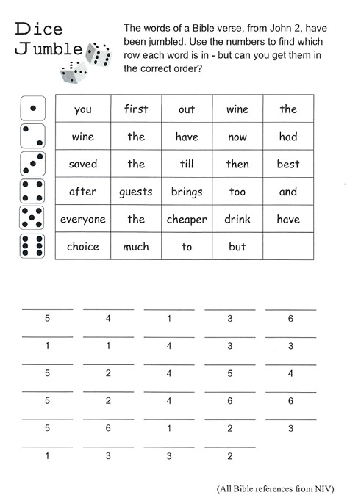
Answer: Everyone brings out the choice wine first and then the cheaper wine after the guests have had too much to drink; but you have saved the best till now.
12
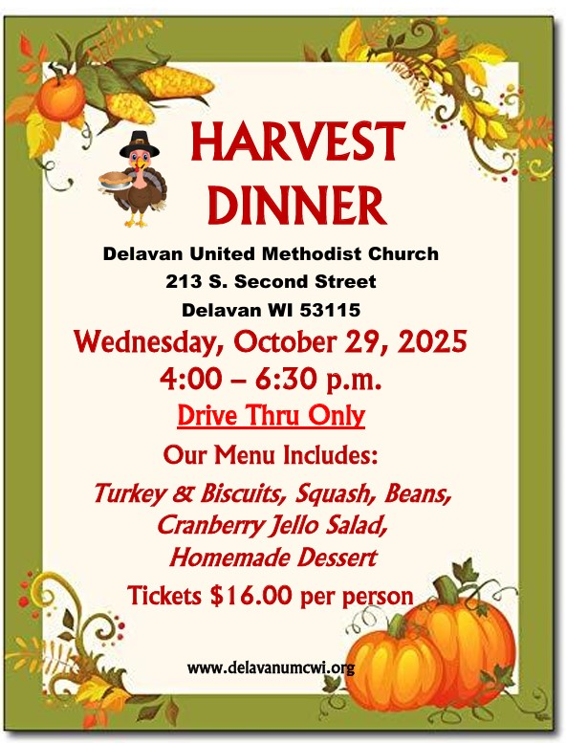
We will need LOTS of help! If you can help, please sign up in the Fellowship Hall. Donations of slab pies, pumpkin or apple bars, butternut squash, and brown sugar are needed. Squash bakers and cranberry salads are also needed. Please sign up to help! Tickets will be available at the church office by October 6th. 2
Congratulations to Joanne Howe for winning 2 Grand Champion Ribbons, Best of Show ribbons, in addition to several other ribbons at the Walworth County Fair for her quilts.
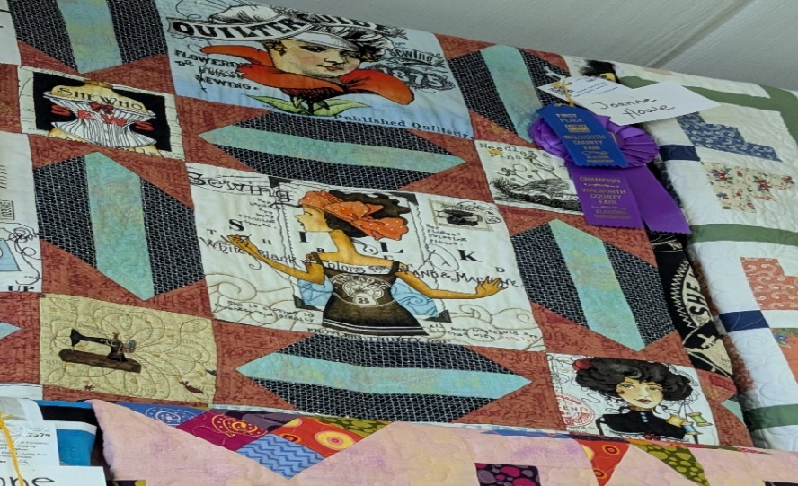

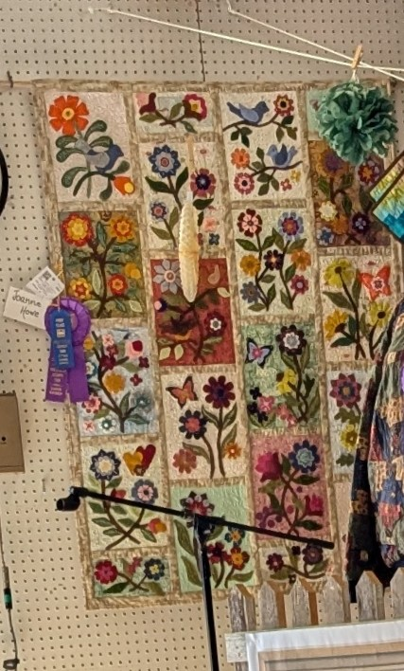

Congratulations also to Krista Edmunds who entered 44 photos at the Fair. Firsts: 24; Seconds: 1; Third & Fourths: 3; and 3 Grand Champions. Congratulations to both of our talented women!

3
UWF (con’t)

We also received the 5 Star Award for faithful giving to the 5 channels of giving. Thank you for the unit for their work on this.
A reminder goes out for our next meeting on Thursday, October 9th at 10:00 a.m. in the church Library. Katrina Willis, Conference MNO will be visiting with us and sharing options for our unit.
On Sunday, September 21st we celebrated United Women in Faith Sunday. Pictured below is our UWF ladies serving coffee hour:
(From left to right) Chris Anding, Barb Foster, Pat Brown, Martha Behlman, Tammy Demet, and Susie Pegel; (Back row) Meryde Hetzler, Carolyn Matthews, and Anita Ryan.

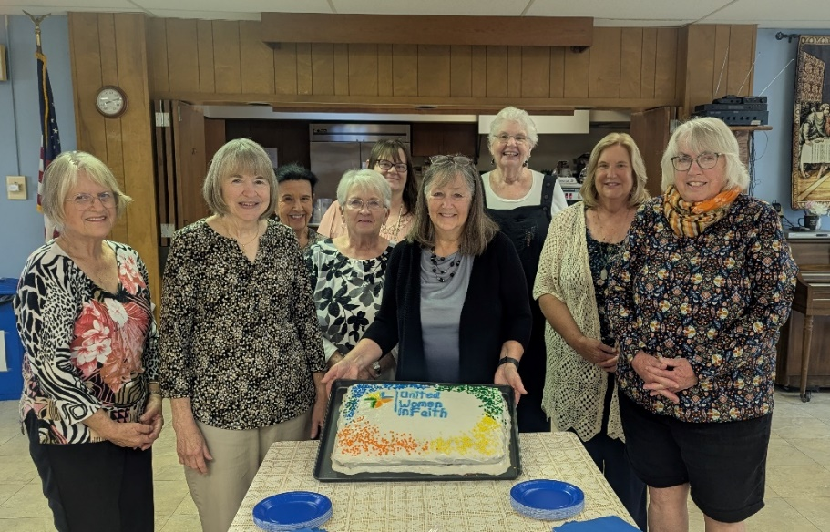



Bible Study is held on Friday mornings at 11:00 a.m. in the Fellowship Hall. We meet for an hour, then meet at an area restaurant for lunch. Please join us!
11

DELAVAN UW FAITH HAPPENINGS – OCTOBER 2025
Next Unit Meeting Thurs. October 9
10 a.m. Church Library

We were so blessed this year to have had a successful Bake Sale Sept. 19-20 during the church rummage sale, and also a wonderful UW Faith Sunday Sept. 21. A big thank you goes out to those who donated baked goods, salsa and bay leaves and to those who donated their time and energy to help out with the Bake Sale. Sue Neiger helped by baking brownies on the spot to increase variety. Pretty much everything sold. We had 22 pies that sold as well as 20 or more breads, cookies, cakes, and bay leaves.
As we worked the Bake Sale, this verse came to mind: Philippians 4: 19: And my God will meet all your needs according to the riches of his glory in Christ Jesus. Another from Corinthians 9:8: And God is able to bless you abundantly, so that in all things at all times, having all that you need, you will abound in every good work. This reminded us that we were working for missions we support that were mentioned at UW Faith Sunday: UMCOR, Northcott Neighborhood House, Rooted & Rising, Wal/Co Child Advocacy Center, the Time is Now, New Beginnings, Twin Oaks Homeless Shelter, the Food Pantry, and our Pledge for Missions to the District. We equip women & girls around the world to be leaders, organizing together to make a difference in their lives, communities and the world. We provide educational experience that leads to transformation; we work for justice through compassionate service and advocacy to change unfair policies also.
At our UW Faith Sunday, Martha Behlman was awarded the Special Mission Recognition pin for her long time continuous and faithful service to the church in many capacities – worship, Sunday School, dinners, UMW events and church rummage sales. Congratulations Martha! You deserve it!
Our unit was recently awarded the Mission Today award at the SE Fall Gathering for accomplishing goals and meeting criteria under Faith, Hope, Love & Action.
(con’t on next page) 10
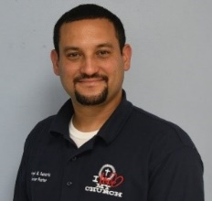
Pastor Angel’s Page
SEASONS
“For everything there is a season, a time for every activity under heaven…a time to plant and a time to harvest.” Ecclesiastes 3: 1-2
King Solomon was the wisest man that this earth has ever seen. I read this scripture that he wrote and think “how much truth is in these words!” Think about this, there are things that you do or don’t like to do. But the issue is that regardless of you not liking them, you have no control of them. For example, I like the time to plant because it reminds me of spring, a time to be outside, enjoy the sun, the warmth, hear the birds sing, and the sky. You can do so many activities outside and the daylight is longer.
The time to harvest, although is a reward of your hard work, it reminds me of fall. Fall is a great season, but it starts to get a little cold, daylight shortens and it means that snow is on its way. For me, the cold, the snow, the bundling up and the blizzards are the things that make me not like this season. The time is hard and kind of boring, but at the same time, is a time to rest from all the outside activities I have done throughout the summer.
What is interesting about this is that it doesn’t matter how much I complain, the seasons will not stop; I can’t control that, I just need to adjust. Although we can’t change the times or the seasons, we do the best to enjoy the season we are in and hope for the ones that are coming in the near future.
Remember that seasons come and go, they don’t last forever. If you don’t like the season you are in your life, just hold on for a moment, for a new season is just around the corner. Spend some time with God in the good times, for when the bad times come you would be used to being connected with the Lord, the source of all good things.
Pastor Angel Rosario 4
Worship Attendance and Receipts
October Worship Participants

Sunday, October 5
Ushers: John Behlman, Greg Matthews, Van Brown
Communion: Chris Anding
Lector: Jesse Guzman
Greeter: Martha Behlman
Coffee: Joan Jones & Friends
Sunday, October 12
Ushers: Dick Martin, Don Edmunds
Lector: Martha Behlman
Greeter: Vernola Anderson
Coffee: Dorie Kosche & Grandkids
Sunday, October 19
Ushers: Jim Aldinger, John Behlman
Lector: Chris Anding
Greeter: Cheryl Davis
Coffee: (volunteer needed)
Sunday, October 26
Ushers: Dale Thompson & Friends
Lector: Anita Ryan
Greeter: Dick Martin
Coffee: (volunteer needed)

Date | Attendance | Receipts
9/7/25 | 31 | $6526.00
9/14/25 | 30 | $1408.00
9/21/25 | 28 | $3035.80
9/28/25 | 36 | $6427.00
Amount that we need each month to meet expenses: $13,879.00. In September we received $17,396.80. Please note that some of the monies received were for the Food Pantry, Noisy Cans, and the Memorial Fund.



Please keep the following members and friends in your prayers:

For healing and strength: Moe Mawhinney, Phyllis Almburg, Van Brown, Don & Jean Hummel, Gene Gallup, Sue Neiger, Ann Scott, Jacob Blair, Leona Kruizenga, Pat Wierenga, Steve Jones, Donna Brellenthin, Paul Holman, Joe Guzman, Jeff Dixon.
NOISY CANS
Every Sunday the Noisy Cans are passed during the offering. The contributions are totalled at the end of the month and benefit a local charity, our Food Pantry, or Pastor’s Discretionary Fund. In September your donations totalled $78 for Big Brothers/Big Sisters of Wal/Co. In October your donations will go to Pastor’s Discretionary Fund. Thank you!

5


Darien Community of Christ UMC will be having their Chili & Chicken Soup Supper on Saturday, October 25th from 4:30 – 6:30 p.m. Tickets are $10.00 per person, and can be purchased at the door.
9

FOOD PANTRY (con’t)

Maybe it was like Abraham when he entertained three men who he thought were strangers, but really turned out to be messengers from God. I give thanks for our guests who are so often gracious and giving to other guests and our volunteers. They often are angels in our midst.
As always, I give thanks for you, our angels who bless this ministry with your support of prayers, food, and finances. Thank you for your ongoing support and your important role in this ministry to the hungry.
Rev. Ed Foster, Coordinator DUMC Food Pantry

Items we regularly need are:

Ketchup/Mustard Hamburger/Tuna Helper
Chunky Peanut Butter Jelly
Salt/Pepper Mushroom Soup
Spaghetti Sauce with Meat Chicken Noodle Soup
Tomato Soup Diced Tomatoes
Elbow Macaroni Refried Beans
Tortillas Fruit Cocktail
Peaches Pork & Beans



8

Be not forgetful to entertain strangers: for thereby some have entertained angels unawares. Hebrews 13: 2 KJV

September showed an increase in the families served. While there were 4 weeks in September, we served 147 families, of which 10 came to the pantry for the first time. That’s an average of 37 families per week; with a couple weeks in the low 40’s for the number of families served.
When we opened at 9 a.m. on Sept. 24, there were 24 guests (total of walk-up and drive-up) in line for food. When we closed at noon, we had served 38 guests. We worked to fill orders without a break. Often the line has a break of 15-20 minutes when we can replenish the shelves from our “overflow pantry,” but not this week. I worked handing out clipboards to guests and welcoming first-time guests. In the line of cars there were 3 cars with dogs in them; one I knew and the other two were new to me. These two were a large New Foundland Retriever and the other had a Chow-Chow.
The car with the Chow-Chow had a mom and her young son (about 3 years old) in it. This car was directly behind the car with the New Foundland. Both cars were near the end of the line, and the little boy needed to use the bathroom. The problem was what to do with the Chow while Mom took her son in the church to use the bathroom. I was about to offer a “dog-sit,” when the woman with the New Foundland spoke up and said that the Chow could join her dog in the station wagon. Luckily, both dogs were very friendly and enjoyed making a new friend, and Mom could take care of her son, while I continued to collect completed shopping lists.
That morning, we entertained an angel unaware: at least until a special need arose and the response was present. Sometimes, I am so focused on the mission of the food pantry, that I overlook the presence of angels in our midst. Last Wednesday was a time that I became aware of God’s support for the pantry in an unusual manner.
(con’t on pg. 8) 6

Sunday | Monday | Tuesday | Wednesday | Thursday | Friday | Saturday
 |  |  | 1  9-12 Food Pantry  7:30 pm AA (CR) | 2 | 3  9 am OA (L)  10 am AA (CR)  11 am BIBLE STUDY (FH) | 4
5  10 am WORSHIP  11 am Fellowship  11:30 am SBP  12:30 pm Spanish Worship | 6 | 7  2 pm Bridging the Gap (FH)  5 pm TOPS (FH)  7 pm Spanish Bible Study (FH) | 8  9-12 Food Pantry  1 pm Delavan Serv. League (FH)  7:30 pm AA (CR) | 9  10 am UWF (L)  5 pm TRUSTEES (FH) | 10  9 am OA (L)  10 am AA (CR)  11 am BIBLE STUDY (FH) | 11
12  10 am WORSHIP  11 am Fellowship  11:30 am SBP  12:30 pm Spanish Worship | 13  5 pm FINANCE COM. (L) | 14  2 pm Bridging the Gap (FH)  5 pm TOPS (FH)  7 pm Spanish Bible Study (FH) | 15  9-12 Food Pantry  6 pm COUNCIL (L)  7:30 pm AA (CR) | 16  1-5 pm Friends of the Library Annual Meeting (FH) | 17  9 am OA (L)  10 am AA (CR)  11 am BIBLE STUDY (FH) | 18
19  10 am WORSHIP  11 am Fellowship  11:30 am SBP  12:30 pm Spanish Worship | 20 | 21  2 pm Bridging the Gap (FH)  5 pm TOPS (FH)  7 pm Spanish Bible Study (FH) | 22  9-12 Food Pantry  1 pm Delavan Serv. League (FH)  7:30 pm AA (CR) | 23 | 24  9 am OA (L)  10 am AA (CR)  11 am BIBLE STUDY (FH) | 25  4:30-6:30 PM Darien UMC Chili & Chicken Soup Supper
Food Pan. Sun. 26  10 am WORSHIP  11 am Fellowship  11:30 am SBP  12:30 pm Spanish Worship | 27  HARVEST DINNER PREP (K) | 28  2 pm Bridging the Gap (CR)  5 pm TOPS (FH)  7 pm Spanish Bible Study (FH) | 29  9-12 Food Pantry  4-6:30 pm HARVEST DINNER  7:30 pm AA (CR) | 30 | 31  9 am OA (L)  10 am AA (CR)  11 am BIBLE STUDY (FH)
SBP=Spanish Band Practice; AA=Alcoholics Anon.; TOPS=Take Off Pounds Sensibly; OA=Overeaters Anon.
K=Kitchen; FH=Fellowship Hall; CR=Community Room; L=Library

